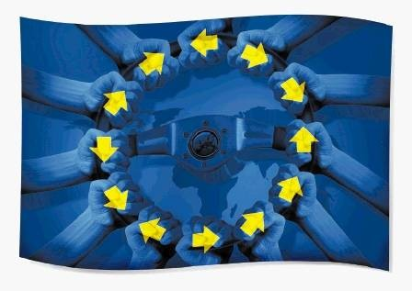
Structural Failings:
Europe’s Lost Billions

As EU member states make savage austerity cuts, the EU spending machine rolls on. €350 billion allocated over 7 years in structural funds alone. These funds, designed to improve skills and economies in Europe’s poorest regions, account for the EU’s second largest budget spend.

But up to now this spending has gone unchecked. The funds cover a vast area - 27 countries, 169 Regions, 23 languages and 500,000 projects - even Brussels doesn’t know who gets it. Up to now nobody has tracked where the money is spent and whether it is all worth it.

In collaboration with The Financial Times, the Bureau of Investigative Journalism has collected hundreds of thousand files, and on the way we have uncovered a trail of waste, mismanagement, fraud and corruption affecting every member state.

The results are striking:

1. SUBDISIDING MULTINATIONALS: some of the world’s most profitable companies are being subsidised by tax-payers. Why do British American Tobacco, McDonalds, Glaxo Smithklein and arms manufacturers receive millions from funds designed to help small and medium sized companies?

2. FUNDING ORGANISED CRIME:
How Italy’s most powerful mafia the ‘Ndrangheta are involved in profiteering and extorting millions off the companies working on the €400,000,000 EU project: the Salerno-Reggio Calabria highway.

How national frameworks (like Law 488) were set up to channel EU funding into politically expedient areas in Italy – and how half of these funds (€500 million) have now disappeared in fraud.

3. EU AND THE ENVIRONMENT:

Projects that Harm: Developments on UNESCO protected areas and National Parks in violation of the rules designed to preserve these very sites.
Toxic waste: EU funded projects that fail to deal properly with waste. Incinerators near population centres, landfill effluent seeping into underground aquifers, and massive levels of dioxins believed to have killed people in affected populations.

Green Dreams: Having promised a 20% reduction in CO² emissions by 2020 the EU is putting it money where its mouth is. Huge subsidies have led to a renewables rush, attracting businessmen with the lure of a quick profit. Amongst them are some of the less reputable entrepreneurs – abusing generous grants, and exploiting their network of corrupt officials to flout regulations.

4. STRUCTURAL FAILINGS:
The EU have created OLAF - a special unit to combat fraud. We show that it is not fit for purpose. Overseeing OLAF, and monitoring EU spending, is a committee of MEP, some of their members have links with organised crime and criminal records. We can show how the EU is almost incapable of monitoring fraud within the EU.

SUBSIDISING THE MULTINATIONALS

Our investigation exclusively reveals for the first time the true extent to which the EU tax-payer is subsidising some of the world’s most profitable companies.

Why do British American Tobacco, McDonalds, Exxon and Tesco receive funds? EU Structural funds are designed to benefit small and medium sized enterprises. Why should technology companies like Microsoft receive millions? Why should the arms manufacturers benefit from these structural funds when they are explicitly excluded?

Our research has shown that the following internationally known businesses are on the benefiting from EU taxpayers:

Company | EU Funding
IBM | €150,000,000
FIAT | €74,000,000
CATERPILLAR | €9,512,025
SIEMENS | €8,562,191
RENAULT | €5,624,439
CARLSBERG | €3,406,601
ERNST & YOUNG | €2,659,592
MICHELIN | €2,519,288
AIRBUS | €2,200,000
AIRBUS | €1,874,097
IKEA | €1,592,581
UNILEVER | €1,000,000

“Tobacco” receives at least €2m across Europe. This includes new processing machines for British American Tobacco in Germany, Portugal and Poland. Why? How does this sit with the EU’s €50 million anti smoking campaign?

The pharmaceutical industry receives over €18,500,000.

Why does the automobile industry receive over €80 million across Europe?

ARMS MANUFACTURERS

We have discovered that at least €45m in European taxpayers money has gone to companies involved in the defence industry breaching EU guidelines that ban any investment in military related activities.

These funds are being used to develop drones capable of dropping bombs, to create component manufacturer supply chains for fighter jet production and centres to develop the next generation of military software.

According to the spokesman for Regional Affairs Commissioner, Johannes Hahn: “These funds do not cover investments in military infrastructure, equipment or activities. “

Despite this, countries such as the Britain, Germany, France and Poland will benefit from European taxpayers money to boost their military stock and their defence industries.

In Britain, the EU is providing 50% of the finance for a €7m project to bring military component manufacturers together to help companies such as BAE save costs on the world’s most expensive defence program ever - the F-35.
The F-35 is a fifth generation stealth fighter jet that is still in development. Financed mainly by the US and British governments, the F-35 will eventually pay a major role in any future military activities.

In France, €2.3m is being spent by SAGEM, one of France’s leading defence manufacturers, to open a centre dedicated to creating high-tech software for combat helicopters, sub-marines and aircraft carriers.

In Poland, weapon-carrying drones with military applications are being created using €2m from the ERDF.

BIG BUSINESS

In Poland and the UK private contractors such as A4e and Reed in Partnership receive €490 million in public funding, but provide sub-standard services that don’t deliver value for money. Over 40,000 UK unemployed have been forced through their programmes - sometime with as few as 2% finding permanent work.

We have evidence of significant top-slicing on EU contracts and National Audit Office reports show that A4e have consistently underachieved, have a poor audit trail and downgraded their contract targets.

These companies have a very aggressive policy to existing charities operating in the same areas. Why were they are awarded contracts in areas where they have no expertise? What is communicated to the European Commission about their poor performance? How did they win their contracts?

Even when fraud has been uncovered there have been no penalties.

FOLLOWING THE FUNDS: HOW MULTINATIONALS PLAY THE SYSTEM
A case study of multinationals relocating to receive funds

H&M will receive €34m of tax payer’s money. To qualify for this massive funding they have agreed to relocate some of their operations from France to Poland. We will go to France to visit the workers affected by H&M’s relocation. We will also look at previous funding periods to show how the relocation of multinationals, as they chase EU tax-payer’s money, is affecting the lives of the people who finance them.

Other examples include Airbus industries who have received funds to relocate, despite a WTO ruling expressly forbidding EU subsidies to airline manufacturers.

FUNDING ORGANISED CRIME

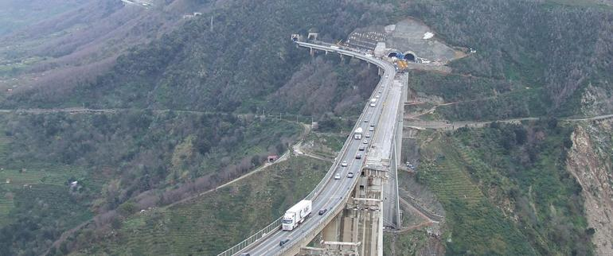
The EU are investing €400,000,000 in a spectacular infrastructure project in Southern Italy; the Salerno-Reggio Calabria highway, carving it through the mountains in a series of tunnels and impossible flyovers from Salerno to the very toe of Italy

The route cuts through the Southern province of Calabria, home to Italy’s most powerful mafia; the Ndrangheta

Traditionally the Ndrangheta have had control over the local construction industry, and they had some success in winning the new construction contracts, jobs for their members and a exploiting a ready market for their shoddy building materials. They then set about “taxing” their competitors; extorting a 3% fee for allowing them to operate in the area. Through this scam alone, the police believe, they have netted over €12m.

One of their competitors was Gaetano Saffioti owner of a medium size construction company. He told us how the Ndrangeheta started negations; “They burnt my excavating machines and my trucks. They threatened my employees, and me. They poured gasoline all over the inside of one of my employees’ car. Our lives were at risk.” He agreed to pay them. When they kept returning for more he decided to secretly film their meetings – as each time he was forced to hand over even more cash. Eventually he took the videos to the police and secured the conviction of 48 people. Saffioti now lives under 24hr police protection.

While filming Saffioti, we happened across another police round up; we filmed a further 52 gang members being arrested for extortion and led from the police station under tight security before being whisked away to prison in a high security cavalcade. The war against the mafia is escalating.

EU funding is seen as easy money for the Ndrangheta, and have been increasingly successful in applying for grants.

Giuseppe Prestanicola, the leader of the Mancuso clan, received €173,000 through his cement company. He was imprisoned for trying to extort money from companies working on the highway and has had €60m of assets seized.

Other people we have access to include Colonnello Papaleo, Head of the Anti-Mafia Division and the Highway Police who monitor work on the highway.

Criminal interests in EU funds aren’t confined to one motorway, or even to Italy.
The terrorist group, the Corsican National Liberation Front have extorted €1.5 million by threatening to bomb projects, and kill workers.

In 2008 , €500m of EU funding was withheld from Bulgaria because organised crime were helping themselves to EU funds while the courts turned a blind eye.
Atanas Atanasov, a tireless anti-fraud campaigner and MP, will take us on a tour of how the EU’s money is being spent on luxury lifestyles, and not on job creation projects as intended.

Law 488
“The EU is just giving money to criminals and no one can be bothered to stop it.”

€500m of EU taxpayer’s money has been allegedly stolen by the mafia and rogue Italian businessmen using funds distributed under Law 488. This fraud, on an unprecedented scale, has been covered-up by the Italian government

Law 488 was rushed through parliament to take full advantage of the EU’s decision to double (to €168bn) the spending in Europe’s poorest regions. Warnings at the time that new law would be abused by organised crime were wilfully ignored.

Law 488 was designed to help grow small and medium sized companies in Italy’s under-developed South, but since its inception in 1992, investigations have revealed that as much as €500m has been “lost”. The head of the Guardia di Finanza has told us that of the 7,000 projects approved 50% have now disappeared.

In August, we filmed, with exclusive access, a Guardia di Finanza raid on five businessmen in Calabria. We can show how these men were tracked down and arrested on fraud charges related to €85m. We filmed their assets valued at €700,000 being seized in one of Italy’s biggest operations of the kind. The police claim they have evidence of €35m in false invoices.

Maresciallo Sorino, Deputy Head of the Guardia di Finanza, says: “The Law 488 is like giving a Ferrari to a child. You are allowing people easy access to something they cannot resist.”

In the early days, the Italian Minister for Economic Development , Pierluigi Bersani, shortlisted for approval the projects that sought funding. He says: “I was happy when the job ended. I didn’t have to sign off any more money. Just so much was being lost to fraud”.

The Italian government is trying to keep a lid on Law 488 fraud by using the Official Secrets Act to bury a government report into the subject. And, contrary to EU rules it is not declaring or repaying the EU money that was lost to fraud.

More raids are planned for the coming months and once again the Italian police are prepared to give us exclusive access.

EU AND THE ENVIRONMENT

GREEN EUROPE

The EU has committed to a 20% reduction in CO² emissions by 2012. To have any hope of meeting this target the EU has had to subsidise thousands of renewable energy schemes. Over €5bn will be spent on a variety of wind, solar and geo thermal projects across union.

Such is the drive to meet these targets many of the normal checks and balances have been swept aside. With high construction subsidies, and guaranteed preferential price for renewable electricity, green power has attracted private investment - and with them fraudsters and money launderers have piled in.

EU Funding the “Ecomafia”

The race to develop windfarms can be seen across Southern and Northern Europe. The scramble to cash in on the subsidies has meant that turbines are frequently built without planning permission and threaten local wildlife. Corrupt local politicians and bureaucrats handing out licenses have never had it so good.

In the last three years, 2,800 wind turbines were built in Italy, many of them owned by the “Ecomafia” – as organised crime involving the environment are labeled in Italy. In Sardinia, recent police raids have implicated government officials and politicians, and given a glimpse of the extent of eco fraud involving EU funds. Our database identifies who received what.

Environmental crime is the second largest area of profit for the Italian mafia. Last year 78 “environmental crimes” took place in Italy. The Ecomafia have muscled in on EU funding as a source of income – and are determined to make the most of it.

Through dodgy waste deals, illegal wind farms and dumping toxic waste, the mafia made an estimated €20million in 2009 and we will expose how much of this has been bank-rolled by the EU tax payer.

Italy. The 2008 crisis of rubbish piling high in the streets of Campania is far from being over. The Ecomafia still controls the market, in 2009 they made investments in waste management estimated at €7 billion.

In April 2010 the EU commission took the unusual step of freezing grants to the area because of the lack of transparency in their accounts. In the next few weeks the EU commission has to decide whether to restart funding for waste services.

GREEN DREAMS

Nature reserves

With Bulgaria’s accession to the EU a number of ‘Natura 2000’ eco-parks were introduced. The Bulgarian nature reserve of Kaliakra is one of them.

Kaliakra ,on the Black Sea, is a place of outstanding beauty and a home to some of the most diverse wildlife in the EU. However in 2007 the boundaries of the reserve were adjusted - excluding some prime building sites from reserve. EU funded construction in the area soon followed. At present, 364 construction projects, most without Environmental Impact Assessments, have been granted planning permission.

Among these developments are EU funded wind farms and three luxury golf courses.

Spain. UNESCO attempted to preserve whole areas of Spain’s habitat when they declared them a Biozone. This status is designed to encourage tourism, increase biodiversity and protect the environment by restricting development.

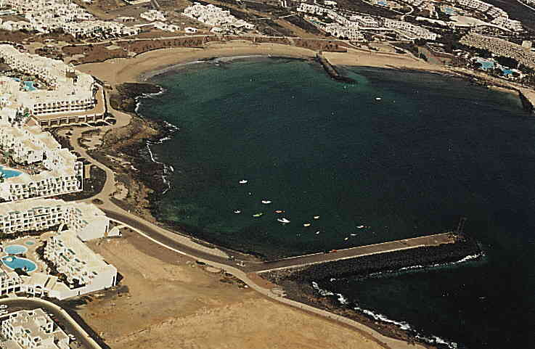
Together with the Financial Times, the Bureau of Investigative Journalism have identified luxury hotels in Lanzarote that were allocated over €25m of EU subsidy. These hotels were built on land designated a UNESCO Biozone. Developers used illegal planning permission granted by corrupt officials.

The remote Spanish island of El Hierro, is set to become Spain’s first island to be powered entirely by renewable energy. Behind the scenes, the deals have been fraught with nepotism, corruption and blatant disregard for the island’s protected environment. The politicians behind the deals have ensured that the windfarms go ahead by reclassifying protected land, adjusting the register of endangered species and granting contracts to their colleagues.

Now the island is littered with wind turbines, erected with no proper planning in a nature reserve, endangering wildlife and outraging the island’s residents.

Incinerators; Burning Europe’s bridges to a greener future

While the EU is driving the green agenda, much of the waste management budget is controversially being pushed into environmentally unfriendly incinerators.

EU funded waste disposal projects are creating havoc with the environment and population. In Acerra, Southern Italy, official sources claim that they are facing an “apocalyptic scenario”. Years of mismanagement have caused dioxin levels in local residents to rocket, exceeding safe levels by a factor of 25, (close to the levels seen in Vietnam veterans from napalm exposure), causing documented premature deaths and high cancer rates in affected areas.

€270m of EU structural funds have gone to building an incinerator in the area. Opened in 2009 it is seriously malfunctioning. Senior officials involved are currently being prosecuted for not conducting a proper tender process, not having an environmental assessment report, and not having the minimum safety standards in both operations and emissions.

In addition, Italians have used EU funding for dumping waste in landfill on UNESCO heritage sites (Near Vesuvius), Other landfill sites that allow biomass effluent to seep into underground aquifers. The entire sector is fraught with fraud and mafia connections.

Companies like Italy’s Recam SPA, is being prosecuted for re-labeling (downgrading) toxic waste. They have then both incinerated it and mixed it with building materials causing untold environment damage in Southern Italy. Our database reveals that they continue to receive EU funding - €1.8 million from the current budget.

The EU turns a blind eye.

In Eastern Europe German and Russian businesses have successfully lobbied the EU for the construction of more controversial incinerators.

Countries from the former Soviet bloc tend to have recycling rates close to zero, but rather than tackling the problem, Europe’s taxpayers are now funding economically unviable and environmentally dubious projects.

Poland's recycling rates are currently the lowest in the EU, and are not set to improve. After intense lobbying by a German manufacturer, Remondis, 75% of its waste management budget (€1.6 billion) is now earmarked to building incinerators.

With nine incinerators planned around residential areas, Polish residents are increasingly concerned about their exposure to toxic emissions.

In Lithuania, Russian owned Gazprom are in line to receive 50% of the EU waste management budget for the development of two incinerators. Plans for these incinerators show them approximately 600m from housing.

EU Funding the rich

Sicily. Luxury golf course and hotels have been built in protected areas - infringing local laws – and subsidised by the EU taxpayer.

Spain. EU funds have helped pay for illegal hotels and unplanned developments in nature reserves. In O Porrino, €300,000 was spent on an unplanned development in a nature reserve. Today the building stands abandoned, dilapidated and covered in graffiti. What should have been a resource for the community, has become an eyesore due to corrupt building practices.

LACK OF ENFORCEMENT

Institutional Failings

OLAF, the EU’s Anti-Fraud Office, has a €50m annual budget to fight fraud and corruption. With just 25 investigators focusing on structural fund fraud in 27 countries and with €350bn to keep an eye on, OLAF is hopelessly under resourced. It is not fit for purpose.

Even if it had the resources it doesn’t have any weight. OLAF’s hands are tied; they have limited powers and no legal clout. They cannot prosecute; this is left to the member states. On top of all this, as OLAF’s own commissioner admits: “It is dogged by incompetence and cronyism”.

We will take a hard look at how EU fraud is monitored and controlled by OLAF, and with evidence from EU whistleblowers expose how they do not, and cannot do their job.

The rot doesn’t stop with OLAF. The EU’s budget is monitored by the Budget Control Committee comprised with MEPs tasked with fighting fraud. It is headed up by the former Italian Magistrate, Luigi di Magistri, MEP famous for putting leading mafia figures behind bars.

- However, one of his team has been convicted, and imprisoned for fraud involving an EU funded project, and wiretaps prove his links to the mafia.

- We will expose how another MEP while tasked with fighting fraud was also being investigated by OLAF for a €3.4m fraud, and how officials in Brussels and his home country tried to block the investigation.

- Another person involved in the same fraud was given a senior position close to the OLAF investigation while it was taking place.

- We will show how one EU official helped friends win EU funded projects, was found guilty by a national court, and despite OLAF’s protestations was never disciplined, but given a promotion instead.

The courts back in member states have their own problems when it comes to prosecuting fraud. Charles Duchaine, a French magistrate, says: “There is no political will here to prosecute fraud. These cases are too complex, and often there is no result.”

National abuse of funds

We can reveal how Berlusconi’s government and the Forza Italia have used EU funds to plug the Italian national deficit and fulfill their election promises. They have funneled European Social Funds from the country’s poorest region into the coffers of the Italian exchequer. €25 billion of EU tax-payer’s money has been misused by the Italian government.

In addition, according to leaked official documents, the EU helped fund through the Italian Government the expansion of the US Air Forces’ base in Dal Molina.

This is all against EU regulations.

The Bureau can show how many projects promised by the Italian politicians but bankrolled by EU taxpayers.

Mismanagement

We will also look at how taxpayers money is wasted through mismanagement.

Arinaga Pier in the Canaries cost over €20m; the pier has never been used, it was surplus to requirement when commissioned, and then built to the wrong dimensions. EU officials have frozen further payments on the project but the Canarian authorities continue to bill EU for the blunder and charge €2m/year for maintenance and security.

The second Danube bridge link between Bulgaria and Romania was launched in 1999 as a flagship EU quick-start project promoting regional integration. It's still unfinished. Construction by the Bulgarian side is advancing, but the Romanians are years behind schedule (they wanted a different location). Bulgaria urgently needs to allocate an additional €200m for transport projects by the end of this year or they will be lost altogether. That would mean no budget to complete the bridge. "At the moment we risk leaving a white elephant sitting in the middle of an important European waterway" said a Bulgarian official.

While the Commission has apologised for previous misuse and waste of tax-payers money, we can reveal that luxury hotels and golf clubs continue to receive millions in EU funds.

The Blacklist

The EU does little more than lip service when it comes to monitoring people who have defrauded EU funds. There is a “Debarment list” but as of March 2010 it only contained the name of one individual.
With no effective blacklist held by the EU, and the funds are open to repeat offenders. We can prove that this shortcoming has cost the EU taxpayers dearly.
In London, UK a re-training company for the unemployed has been associated with serial fraud, yet the owner continues to receive funds. Between 2000-6 the London East Ethnic Business Association (LEEBA) was awarded €400,000 for ERDF projects. A host of dubious smaller companies offering re-training courses were given the money which has not been tracked since. This was never reported to the European Commission or OLAF. The Bureau has uncovered that the man behind LEEBA, Shaukat Khan continues to apply and receive funding because he has never been stopped.

Recam SPA, is being prosecuted for dumping toxic waste, but our database reveals that they continue to receive EU funding for waste management - €1.8 million from the current budget.

Tax Payers left to foot the bill

Member states have to repay the EU for funds that have been proven to be mismanaged.

But the vast majority of those that have stolen or misappropriated the funds are left untouched. From 2006 to 2008, 49 cases handed over by OLAF to national prosecutors were dismissed by judges on the grounds that they were not in the public interest, lack of evidence or had taken too long to reach them.

Known fraud over this period amounted to €298.56

Is it making a difference?

Despite the fact that cohesion funds are there to encourage a level playing field between member states, some all regions in the EU receive structural funds. Germany, Lüneburg, one of the richest areas of the EU, was granted a staggering €900 million between 2000-2006.

An OECD report has indicated that at the current rate of convergence, it would take 170 years for the EU funds to achieve their stated aims.

Access:
We are in negotiations with the European Parliament's Budget Control Committee to accompany a delegation of MEPs to Italy in October to film their meeting with government officials while investigating fraud. In the past, these delegations have encountered resistance and obfuscation.

The Bureau of Investigative Journalism

Approach

This document is intended as the basis for further discussions

We are open minded as to how this film is made.

While it could be one person’s authored journey to discover what happens to their tax, it could also be a series of films, each one concentrating on a particular theme.

The Bureau and its staff have a great deal of experience working with British and US broadcasters, but only limited exposure to ARTE. With this in mind we would consider working with a director who has a thorough knowledge of ARTE’s ethos and approach.

However we are attaching three CVs of people from the Bureau who have developed these stories, and could also produce and direct this project.

Profile

The Bureau of Investigative Journalism is a London based not-for-profit organisation that aims to produce original journalism by producing high-quality investigations for national and international press and broadcast media.

Since its launch in April 2010 it has already produced investigations for Channel 4 News, Aljazeera, and has commissions for the BBC’s flagship investigative journalism programme Panorama, Channel 4’s Dispatches.

Other investigations have already been published in the Financial Times and the Sunday Times.

The bureau functions as a production house working in collaboration with other news groups to get its investigations published and distributed.

The Bureau has a team of over 20 award winning, multi-lingual producers, directors and journalists working across several major investigations, but at its core are editor Iain Overton and lead reporter Angus Stickler, a former BBC correspondent.

www.thebureauinvestigates.com

